**SUMMARY REPORT AND FINDINGS OF ANALYSIS FOR USED CARS IN INDIA FROM 1996 TO 2019**

**THE METHOD AND TOOLS USED IN MY ANALYSIS**

In this analysis, I utilized **Power BI** to create interactive and visually engaging charts based on the dataset. First, I loaded and cleaned the data, ensuring accurate representation across multiple categories: **fuel type**, **location**, **transmission**, mileage, year, owner type, and **price**. I used bar charts, pie charts, line charts, tree maps, and slicers to break down key metrics like the **average price by location**, **sum of price by transmission type, Sum of price by year, count of names by the fuel type, Total price by the car name, Total price by transmission, Total price by millage, and count of car name by owner’s type**. This allowed for in-depth comparisons and identification of patterns. I also leveraged **filters** and **slicers** to drill down into specific data segments, such as focusing on the **top 5 car names** with the highest price. Then I used the format visuals to format my text and heading and also give the borders of the chart. I used the Card Charts to highlight the average figures in the data. The insights were derived by observing the charts' trends, abnormalities, and correlations, making the findings actionable for business decision-making.

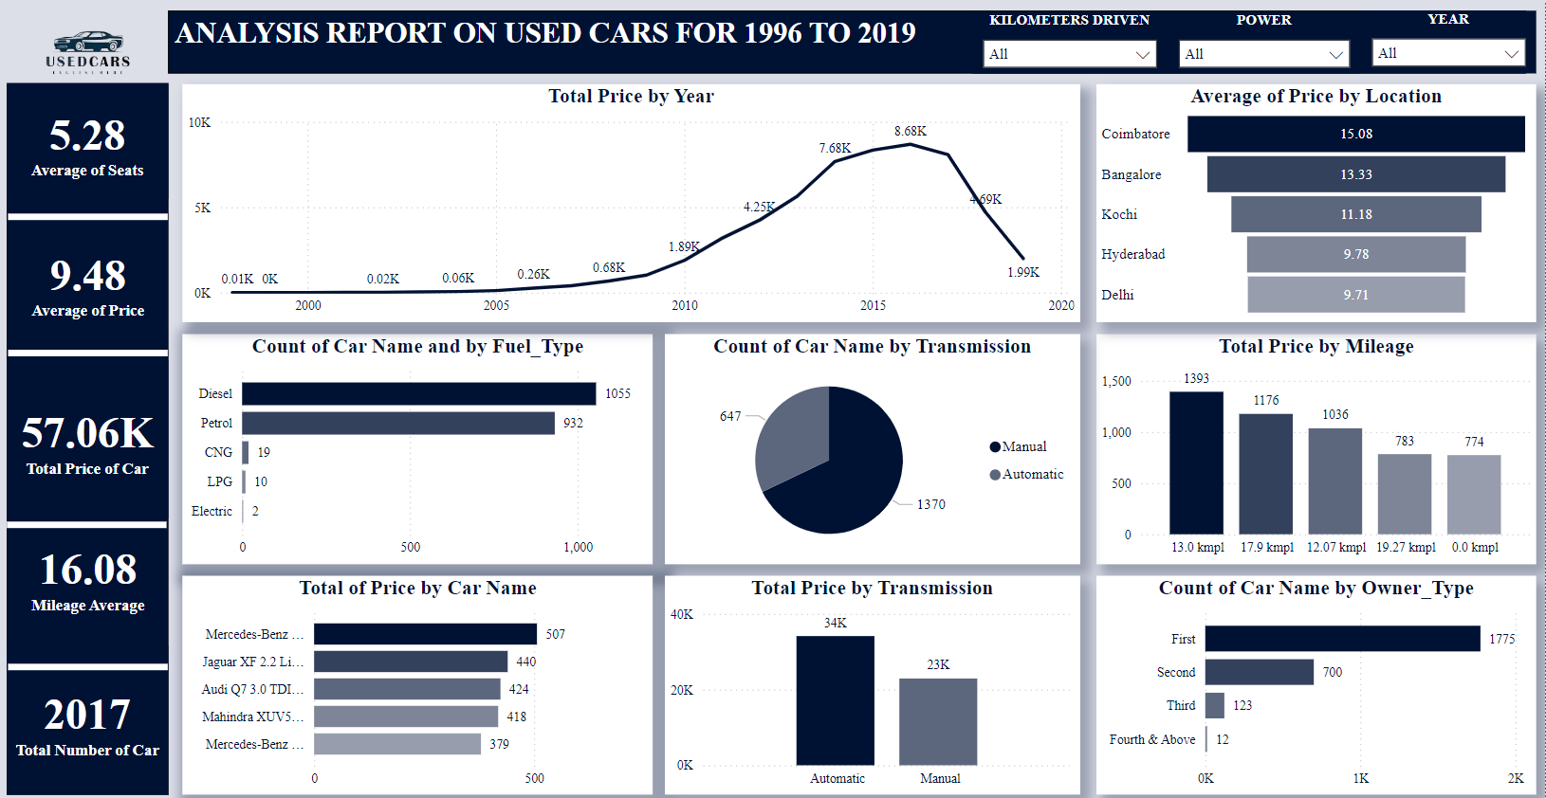

**KEY FINDINGS**

**1. Average Car Price and Maximum New Price**

* ***Findings:*** The average car price is ₹9.48K, with the highest new price at ₹1.6 crore.
* ***Brief Explanation:*** This shows a broad range in pricing, indicating both budget and luxury vehicles in the market. The high maximum new price suggests a presence of premium or luxury cars, likely in more affluent markets.
* ***Implications for Decision-Making:*** This can guide pricing strategies, as targeting both ends of the market (budget and premium) can help capture different customer segments. Further investigation could focus on customer preferences across these segments to refine product offerings.

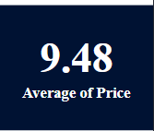

A card from the report

**2. Seating Configuration**

* ***Findings:*** Most cars have 5 seats, with an average of 5.28 seats.
* ***Brief Explanation:*** A standard seating capacity of 5 seats is typical in most passenger vehicles, indicating the broad appeal of mid-sized cars. The slight increase in average seating might reflect an emerging trend toward larger vehicles.
* ***Implications for Decision-Making:*** Manufacturers can focus on mid-sized cars or target larger seating capacities for families. This could help refine inventory decisions based on customer demand for larger vs. smaller vehicles.

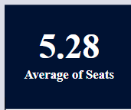

Average seat card

**3. Engine Capacity and Mileage**

* ***Findings:*** The average engine capacity is 1617cc, with an average mileage of 16.08 km/l.
* ***Brief Explanation:*** The engine size indicates a mix of performance and efficiency, while the mileage is relatively good, showing that most vehicles offer decent fuel economy. This could appeal to cost-conscious buyers.
* ***Implications for Decision-Making:*** Marketing efforts can highlight fuel efficiency in advertisements to attract budget-conscious customers. Further analysis could explore consumer preferences for engine size and fuel efficiency to help decide which cars to promote more aggressively.

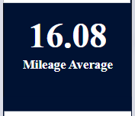

Average mileage

**4. Price Trends by Year**

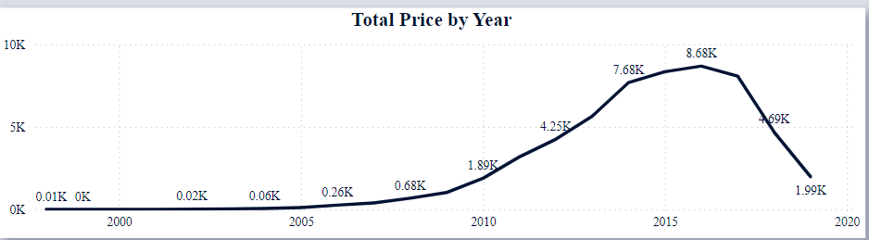

* ***Findings:***The total price was highest in 2016 (₹8.6K), while the years 1996-1998 had the lowest sum of prices, under ₹100.
* ***Brief Explanation:***This shows a significant depreciation in car prices over time, especially for older models. The peak in 2016 could reflect a surge in car production, availability, or consumer demand during that period.
* ***Implications for Decision-Making:*** Businesses can focus on more recent models for higher price points, and consider offering discounts or promotions for older cars to increase sales. This could also help identify the most profitable years for vehicle acquisition.

**5. Average Price by Location**

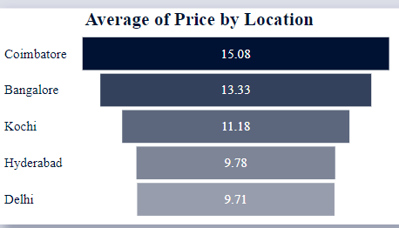

* ***Findings:***Coimbatore has the highest price average (15.08%), followed by Bangalore (13.33%), with Delhi having the lowest at 9.71%.
* ***Brief Explanation:***This indicates regional price variations, possibly due to differences in local demand, car type preferences, or economic conditions. Coimbatore's higher prices suggest a wealthier consumer base or demand for luxury cars.
* ***Implications for Decision-Making:*** Marketing efforts can be tailored to each region, focusing on premium vehicles in high-price areas like Coimbatore and more affordable options in cities like Delhi. This can drive sales by aligning the product offerings with regional demands.

**6. Fuel Type Distribution**

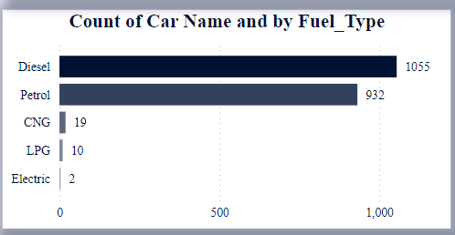

* ***Findings****:* Diesel cars dominate (1055), followed by petrol (932), with very few CNG (19) and electric cars (2).
* ***Brief Explanation:***Diesel continues to be the preferred fuel type, likely due to its efficiency for long-distance travel, while petrol is common for smaller or less expensive vehicles. The low number of electric cars suggests limited adoption, possibly due to higher upfront costs.
* ***Implications for******Decision-Making:*** Companies should focus on stocking and promoting diesel and petrol vehicles to meet demand. The low number of electric cars might signal an opportunity to promote or invest in electric vehicle (EV) marketing, as the market is likely to grow over time.

**7. Total Price by Transmission**

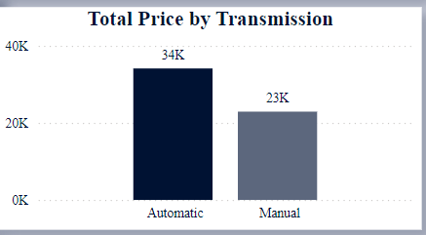

* ***Findings:***Automatic cars have a higher total price (₹34K) compared to manual cars (₹28K).
* ***Brief Explanation:***Automatic cars are generally seen as more convenient and user-friendly, making them more desirable, especially in urban areas with heavy traffic.
* ***Implications for Decision-Making:*** Focusing on automatic vehicles can yield higher profits, particularly if they are marketed as offering superior comfort and ease of use. Further research into consumer preferences for transmission types can help tailor inventory to meet market demand.

**8. Count of Cars by Transmission**

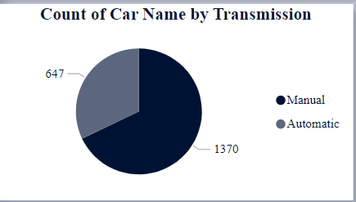

* ***Findings:***1370 manual cars and 647 automatic cars.
* ***Brief Explanation:*** While there are more manual cars, automatic cars tend to be priced higher. This suggests that while automatic cars are fewer, they appeal to a more affluent demographic or are seen as more valuable in the marketplace.
* ***Implications for******Decision-Making:*** Stocking more automatic cars could increase profit margins, while still maintaining a balanced stock of manual cars to meet the preferences of cost-conscious buyers.

**9. Ownership by Count**

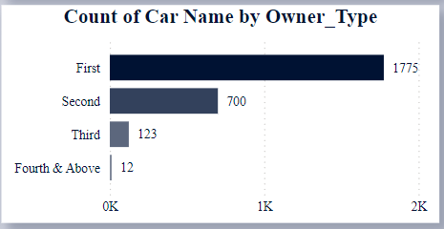

* ***Findings:***First owners (1775) make up the largest share, followed by second owners (700), and very few cars with third or more owners.
* ***Brief Explanation:*** *:* First-owner cars are likely to be newer, better maintained, and carry higher resale value, while cars with multiple owners might show signs of depreciation or wear and tear.
* ***Implications for Decision-Making:*** Targeting first-owner cars could appeal to customers looking for quality and reliability. Additionally, businesses could offer promotions for second-hand vehicles, particularly if they are well-maintained, to expand their customer base.

Each of these observations can inform different aspects of business strategy, including inventory management, pricing, marketing, and customer targeting.

**RECOMMENDATION FOR DECISION MAKING**

**1. Concentrate on Popular Fuel Types for Increased Sales Potential**

* ***Brief Explanation:*** Diesel and petrol cars are the most common, with diesel cars leading. This suggests that there is a higher demand for these fuel types, and marketing efforts can be directed toward this audience.
* ***Decision-Making:*** Businesses can focus on acquiring more diesel and petrol vehicles to match demand. Understanding the regional variations (such as areas where diesel is more popular) could help target marketing campaigns and inventory stocking more effectively. Further investigation into evolving fuel preferences (such as a rise in electric vehicles) would be beneficial for long-term planning.

**2. Target Urban Areas for Higher Costs**

* ***Brief Explanation:*** Coimbatore and Bangalore show higher average car prices, suggesting these cities have a wealthier consumer base that demands premium cars.
* ***Decision-Making:*** Focus marketing efforts and premium vehicle inventory in cities with higher prices. In these regions, targeting consumers who can afford higher-end vehicles or luxury cars can lead to increased sales. Further investigation could involve analyzing other potential high-demand urban areas with similar price trends.

**3. Promote Automatic Cars**

* ***Brief Explanation:*** Automatic cars are generally more expensive but are in demand due to their convenience and ease of driving, particularly in urban areas with heavy traffic.
* ***Decision-Making:*** Marketing strategies should highlight the advantages of automatic cars, such as convenience, comfort, and ease of driving, to appeal to customers in busy urban environments. Additionally, increasing the stock of automatic cars, especially in higher-demand regions, can help tap into this lucrative segment.

**4. Examine the Manual Transmission Niche**

* ***Brief Explanation:*** Although manual cars are priced lower, there is still demand for them due to factors like lower price points or personal preferences.
* ***Decision-Making:*** Targeting niche markets where manual cars are popular (such as in rural or less urbanized areas) could help balance inventory. For higher-priced manual cars, highlighting their rarity and quality could attract specific buyers looking for a unique or traditional driving experience. A deeper dive into customer behavior could reveal further opportunities.

**5. Focus on Luxury Car Brands**

* ***Brief Explanation:*** Car brands that fall under the "Top 5 Highest Price" category are performing well in terms of total price, indicating a market for luxury or high-end vehicles.
* ***Decision-Making:*** Maintaining a stock of high-end luxury car brands in areas with a demand for expensive cars can help businesses attract affluent customers. Further investigation into customer preferences for luxury features (such as brand reputation, design, or technological advancements) could guide future stock decisions.

**6. Take Mileage into Account When Setting Prices**

* ***Brief Explanation:*** Low-mileage cars tend to have a higher total price, likely because they are perceived as being in better condition and having a longer lifespan.
* ***Decision-Making:*** Pricing strategies should factor in mileage, with lower-mileage cars positioned as premium offerings. Marketing these cars as more durable and valuable due to their low mileage could attract buyers willing to pay a premium for better condition. Further analysis of how mileage impacts car value across different brands and models would enhance pricing strategies.

**7. Stock Popular Car Brands**

* ***Brief Explanation:*** The data suggests that certain car brands consistently generate higher sales and prices, making them more profitable.
* ***Decision-Making:*** To maximize profitability, focus on maintaining inventory for these top-selling car brands. This aligns with customer demand, ensuring that popular vehicles are readily available. Investigating the features that make these brands popular (such as reliability or style) can help refine inventory stocking further.

**8. Dealer Partnerships**

* ***Brief Explanation:*** A large number of vehicles are owned by single owners, which could indicate an opportunity to form partnerships with dealerships that sell bulk inventory.
* ***Decision-Making:*** Forming partnerships with large dealerships that have access to bulk vehicles could increase sales volume and improve access to a wider variety of car models. Additionally, such partnerships could streamline inventory management by securing larger quantities of in-demand vehicles. Researching potential dealership partnerships in specific regions would be a strategic next step.

**9. Emphasize Low Mileage for Value**

* ***Brief Explanation:*** Cars with low mileage are often seen as more desirable due to their perceived longer lifespan and better condition.
* ***Decision-Making:*** Marketing campaigns should highlight low-mileage cars as valuable investments, focusing on their durability and long-term cost savings. Emphasizing these benefits in promotions could help sell cars at a higher price. Tracking consumer sentiment around mileage preferences can help refine marketing and inventory strategies.

**10. Offer Promotions or Financing for High-Mileage Cars**

* ***Brief Explanation:*** High-mileage cars are generally less desirable but can still offer value to cost-conscious buyers, especially if they are priced attractively.
* ***Decision-Making:*** Offering financing options or discounts on high-mileage vehicles can help make them more attractive to buyers who are looking for lower upfront costs. Promotions could also include warranty packages or servicing offers to increase appeal. Further investigation into the financing options most attractive to these buyers can enhance the effectiveness of such strategies.

Each of these recommendations is designed to leverage the insights gained from the data analysis, allowing businesses to make more informed decisions regarding pricing, inventory, marketing, and customer targeting. By exploring these recommendations, companies can optimize their strategies for higher sales and better customer satisfaction.

**CONCLUSION**

Conclusively, the findings highlight key trends in used car data, such as the dominance of diesel and petrol cars, urban areas commanding higher prices, and the strong market potential for automatic transmissions. Insights like first-owner vehicles being the most common and luxury car brands having higher demand underline market preferences.

The recommendations suggest focusing on popular fuel types, targeting urban markets, promoting automatics, and emphasizing low-mileage cars for profitability. Dealer partnerships and incentives for high-mileage cars are also advised to maximize sales opportunities.

This analysis supports strategic pricing, inventory planning, and marketing for improved sales outcomes.